

Shell Scripting

BCSE303P Operating Systems



***Name: Chillara V L N S Pavana Vamsi***

***Register Number: 21BCE5095***

1. Read n strings and display the strings which are palindrome.

#!/bin/bash

echo "Enter the number of strings:"

read n

echo "Enter the Strings:"

for ((i=0;i<n;i++))

do

read string

reverse=$(echo $string | rev)

if [[ $string == $reverse ]]

then

echo "$string is Palindrome"

else

echo "$string is not Palindrome"

fi

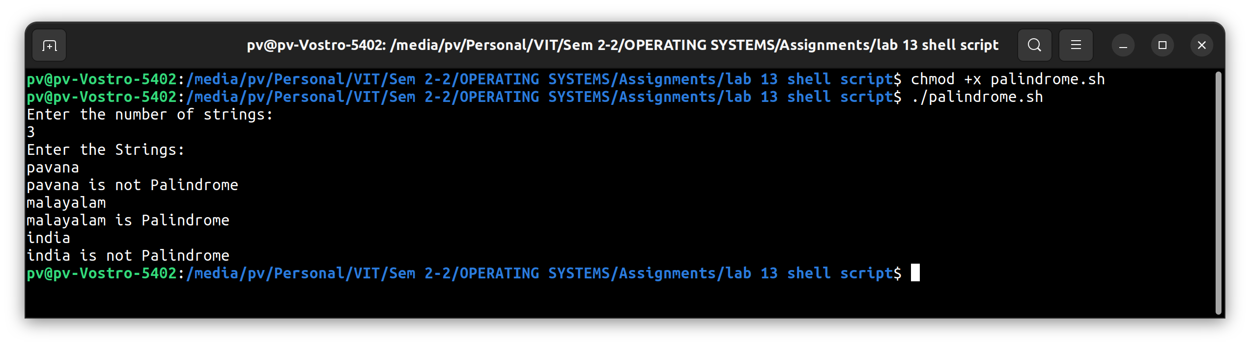done

1. Check the given number is prime or not.

#!/bin/bash

echo -e "Enter number: \c"

read n

for((i=2;i<n;i++))

do

if [ $((n % i)) -eq 0 ];

then

echo "$n is Composite"

exit 0

fi

done

echo "$n is Prime"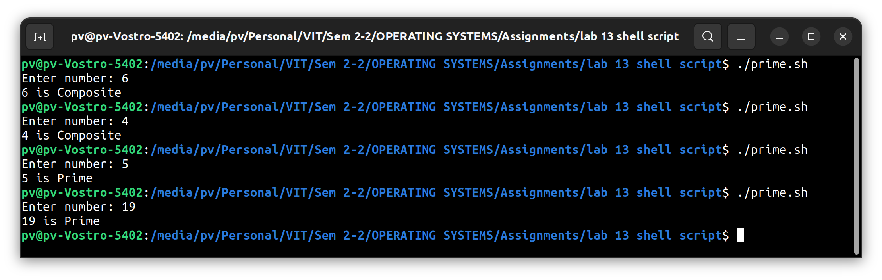

1. Check the given number is Armstrong or not for a 4 digit number. (Ex. Armstrong numbers with 4 digits are 1634, 8208, and 9474)

#!/bin/bash

echo -e "Enter a number:\c"

read n

length=${#n}

sum=0

for ((i=0;i<length;i++))

do

digit=${n:$i:1}

sum=$(echo $sum + $digit^$length | bc)

done

if [ $sum -eq $n ];then

echo "$n is a amstrong number"

else

echo "$n is not amstrong number"

fi

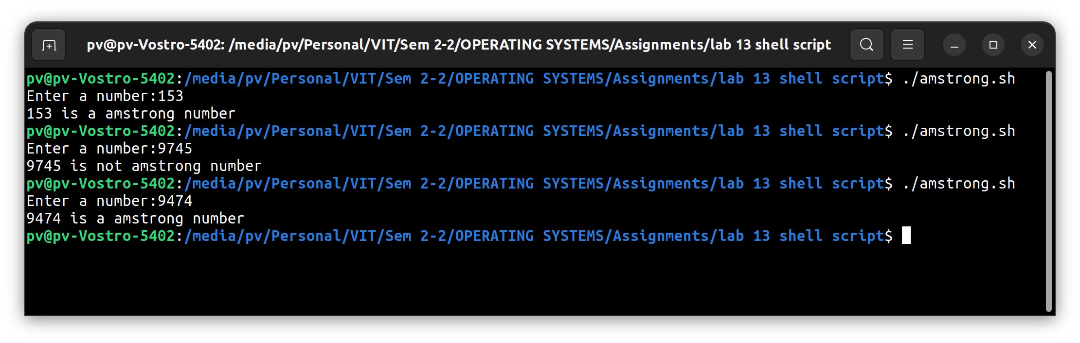

1. Display the factors of the given number

#!/bin/bash

echo -e "Enter the value of n:\c"

read n

for ((i=1;i<=n;i++))

do

if [ $((n%i)) -eq 0 ];then

echo -e "$i "

fi

done

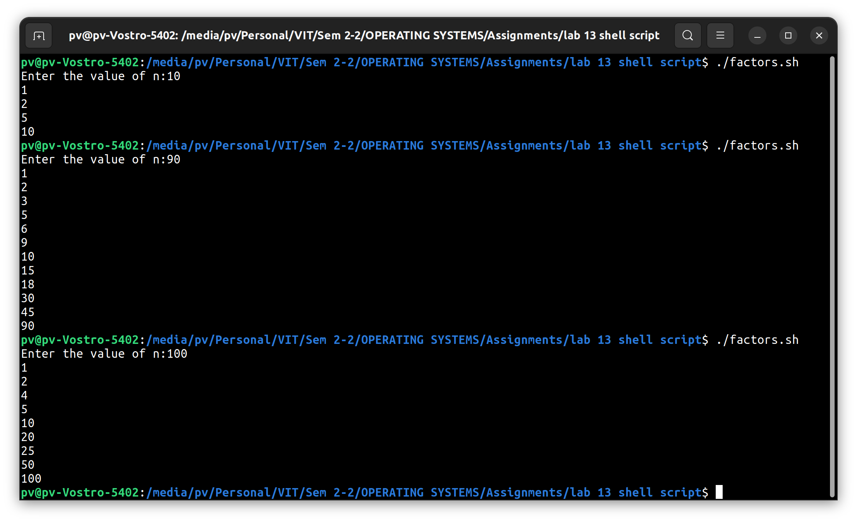

1. Assuming a 1 KB page size, what are the page numbers and offsets for the following logical addresses references. Develop a shell script for the same.
2. 21942
3. 5500850

echo -e "Enter the number of inputs:\c"

read n

echo -e "enter the page_size:\c"

read m

a=$((m*1024))

for ((i=0;i<n;i++))

do

echo -e "Enter the logical addr:\c"

read x

pgno=$((x/a))

offset=$((x%a))

echo "Page no:$pgno"

echo "Offset:$offset"

done

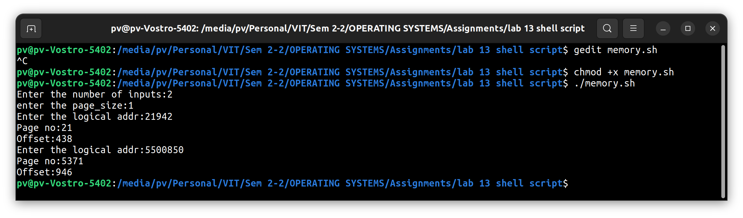

1. Assume that a system has a 32 bit virtual address with a 4kb page. Write a C program that is passed a virtual address (in decimal number) on the command line and have it output the page number and offset for the given address. As an example your program shoulld run as following

•./a.out 19986

The program output should be

The address 19986 contains:

Page number = 4

Offset = 3602

#include <stdio.h>

#include <stdlib.h>

int main(int argc, char *argv[])

{

    int n, pgsize = 4, addr, pgno, offset;

    pgsize *= 1024;

    for (int i = 0; i < atoi(argv[1]); i++)

    {

        addr = atoi(argv[i + 2]);

        pgno = addr / pgsize;

        offset = addr % pgsize;

        printf("Page size:%d\nOffset:%d\n", pgno, offset);

    }

    return 0;

}

